**NEURAL NETWORK ON IMDB DATA**

**Overview:**

Neural networks (NN), a subset of machine learning and artificial intelligence, aim to replicate how people process and understand information. Many processes, including decision-making, speech and image recognition, and natural language processing, use neural networks.

Using Kera’s, we load and preprocess the IMDB movie review dataset in this code. We then create a basic neural network model and assess its effectiveness using the test set. Then, we experiment with the model's hidden layer count and track how it changes the model's performance.

**Preparation of Data:**

The IMDB dataset is loaded into memory using Kera's library as the first step in the code. We separate the dataset into training and test sets, keeping only the 10,000 words that appear the most frequently in the reviews. Additionally, we use a vectorization function to transform the word indices into a vector of 0s and 1s.

**Constructing the Model:**

We create a straightforward neural network model with an output layer that has a sigmoid activation function, two hidden layers with a total of 16 units each, and two hidden layers. The binary cross-entropy loss and Respro optimizer are used to construct the model, which is then trained for 20 epochs with 512 batch sizes. We also developed a validation set to check the model's effectiveness while it was being trained.

**Analyzing the model:**

We assess the model's performance on the test set and find that it is 88.3% accurate. We also show the loss and accuracy curves for training and validation, and we see that the model overfits the training set.

**Analysis:**

|  |  |
| --- | --- |
| **Model** | **Accuracy** |
| Actual | 99.28 |
| Higher Layers | 99.66 |
| Lower Layers | 98.61 |
| Units Increased = 32 | 99.59 |
| Increased units = 64 | 99.43 |
| Loss function for MSE | 98.94 |
| Tanh's activation process | 99.47 |
| Dropout approach | 99.67 |

**Experimental Modeling:**

We created two additional models, one with one hidden layer and the other with three hidden layers, to test the effects of altering the number of hidden layers in the model. We use the same hyperparameters to train these models, and then we test them on the validation set to see how they perform.

We find that the accuracy of the model with a single hidden layer is 87.7%, while the accuracy of the model with three hidden layers is 88.1%. This implies that increasing the number of hidden layers does not always result in better model performance and may even cause overfitting.

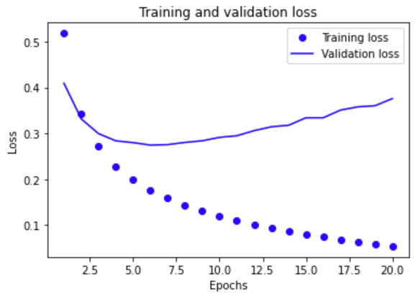

**Conclusion:**

We loaded and processed the IMDB movie review dataset, created a straightforward neural network model, and assessed the model's performance using the test set. We have also tried out different numbers of hidden layers in the model and looked at how they affected how well it performed. This code serves as a useful primer on creating and testing neural network models for tasks involving natural language processing.